* Object

Các hàm xử lý

Hàm

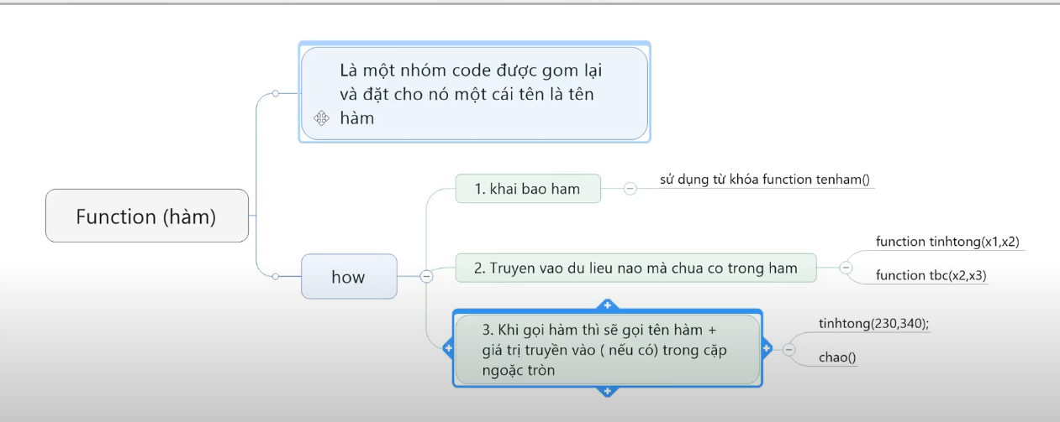

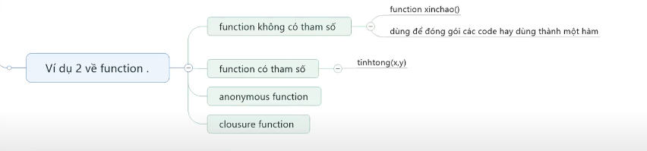

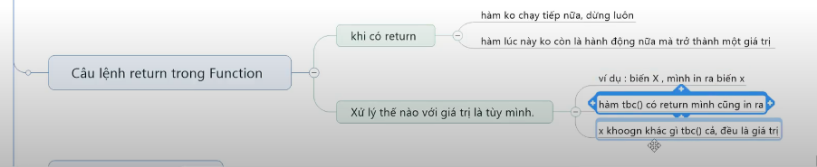

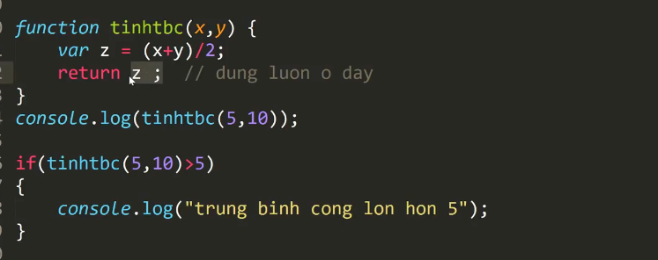

Constructor

Bài 23: 24: 25: viết template để trả về frontend , duyệt mảng từ api giả định

Cấu trúc file html để hiệu ứng facebook

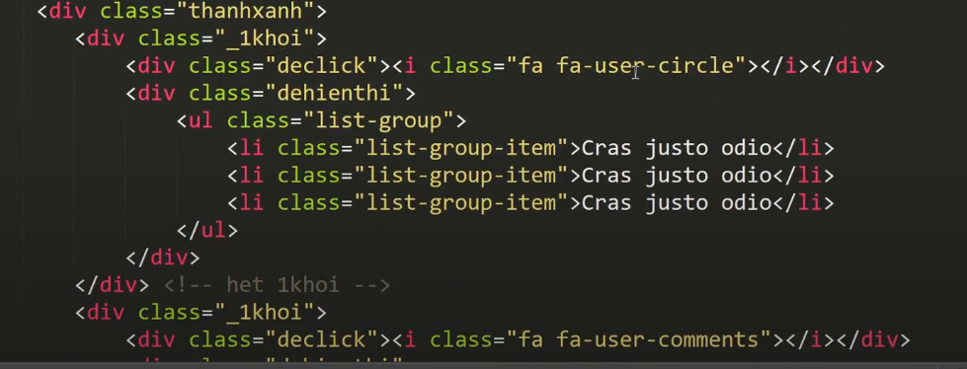

Video 47: xử lý icon thành màu trắng khi click

Video 48: click vào nút khác, nut đang click mất màu trắng

* Xử lý nd hiện ra và thu vào khi clip nut khác

Vd 49: clip vào chính nó sẽ mất đi, 🡪 chia ra làm 2 trường hợp

* Clip vào chính nó
* Click vào đối tượng khác